CFIMA 2021 REGISTRATION FORM
2021 2nd International Conference on Frontiers of Intelligent
Manufacturing and Automation Shenzhen, China
May 22-24, 2021
SECTION 1: BASIC INFO
*Full Name:  *Position:  *Email: | *Affiliation & Nationality:  *Mobile:  *Address & Zip Code (for postal use):

SECTION 2: AUTHOR INFORMATION
* Paper ID: * Paper Pages: * Additional Page(s):
* Paper Title:
* Authors:
* Will you attend the conference in person Yes □ No □
* Presentation Terms √: Oral □ Poster □ Remote Video □ Video □
Conference meal (May 23)√: Lunch □ Dinner □
Special dietary √: Diabetic □ Vegetarian □ Halal Food □ Other □ (please specify: )

SECTION 3: REGISTRATION FEE
Category | HKSRA Member  (Full Paper) | Nonmember  (Full Paper) | Student  (Full Paper) | Presenter  (Abstract) | Listener
Early Registration  (Until Oct.23, 2020) | USD 480 | USD 500 | USD 450 | USD 400 | USD 350
Regular Registration  (Until Dec. 5, 2020) | USD 500 | USD 530 | USD 480 | USD 450 | USD 400
Late Registration  (After Dec. 5, 2020) | USD 530 | USD 580 | USD 520 | USD 480 | USD 450
On-site Registration  (May 22-24, 2021) | USD 580 | USD 610 | USD 550 | USD 500 | USD 480
Online Presentation  (Until May 22, 2021) | USD 350 | USD 380 | USD 320 | USD 250 | USD 200

Extra Page / Per page | Extra Paper Upload | Extra Banquet Ticket | Academic Visit Optional
USD 70 | USD 370 | USD 50 | TBD
*One regular paper is within 6 pages, including all figures, tables, and references. Extra pages will be charged for Additional Pages Fee. The length of long paper should not exceed 12 pages.
*All accepted papers will be published on-line.

Your Total Conference Fees

PAYMENT INFORMATION
Please calculate the amount of your registration fee and finish the payment with Online Payment link http://meeting.yizhifubj.com.cn/web/main.action?meetingId=475
Notice
Please make sure the conference organizer, HKSRA’s logo is always appear on the page until you submit your payment information. Next you will be directed to the payment page.
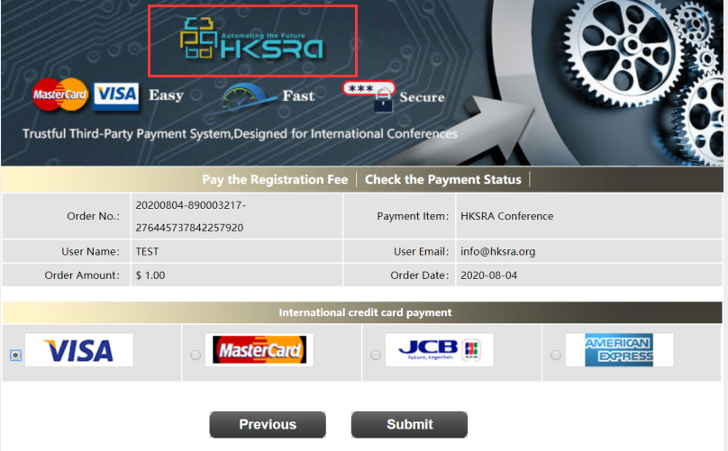

PAYMENT INFORMATION
Please fill in the following blanks after finishing your payment.
* Payment Email:
* Order No.
* Receipt Issued to:
Student ID No.(student only):
HKSRA Member No. (Member only):

SECTION 4: HKSRA MEMBER
HKSRA MEMBER APPLICATION: Join HKSRA now to qualify for member registration rates.
Please compile and return the Membership Form along with your CV to membership@hksra.org. Your application will be processed in 5 working days.

SECTION 5: OTHER
Please provide your one-inch photo for conference use.
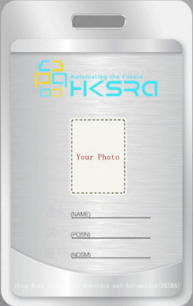
BIOGRAPHY: You are encouraged to write down a biographical sketch here, for the use of making introductions by Session Chair before your presentation. 20-120 Words(1-6.5 lines)

